5/2/2023

Adam Foflonker 12D

Rylands high school

IT PAT

*Powerhouse*



**Task 1A: Scenario and Scope**

The load shedding epidemic in South Africa has flung the country into a full-scale energy crisis, and the average person is being greatly affected by it. The government has been encouraging people to conserve electricity, which is not an easy task since almost all of our appliances and devices require electricity to operate properly. This crisis has highlighted the need for individuals to be more mindful of their energy usage to reduce their impact on the environment and save money on their electricity bills. However, many people lack the tools and knowledge to accurately track their energy consumption and identify areas where they can make changes to reduce their energy usage.

The solution to this problem is ***Powerhouse***. Powerhouse is an electricity calculator application that allows users to input the type of appliance they are using and the amount of time they are using it to accurately calculate their energy consumption and cost and provide them with a deeper understanding of how their electricity costs work. The application will also provide users with tips and tricks for conserving energy and reducing their carbon footprint. By helping users to track their energy usage and providing them with the knowledge and resources to make informed decisions about their energy consumption, Powerhouse aims to empower individuals to reduce their impact on the environment, save money on their electricity bills, and minimize the potential damage caused to their appliances as a result of load shedding.

**Task 1B: User Requirements**

The Powerhouse application will primarily target homeowners. The average homeowner in South Africa cannot afford to install solar panels or purchase inverters. Therefore, Powerhouse will cater to these individuals by helping them to save money on electricity and prolong the lifespan of their appliances as much as possible. Homeowners should know how much power their electrical appliances use, the implications of using these appliances for prolonged periods, and how to reduce their electrical expenses.

During the development of Powerhouse, I interviewed several individuals to determine what features they would like in an application of this nature. The responses I received included:

* "I want to be able to set a budget for my energy usage so that I can stay within my financial means."
* "As a user, I want to receive tips and tricks for conserving energy so that I can reduce my carbon footprint and save money on my electricity bill."
* "I would like to learn more about how my electrical appliances work and the dos and don'ts of
* operating these appliances during load shedding.”

For security reasons, user passwords will not be stored as plain text in the backend database. Passwords will therefore be salted with a dynamic salt, and then hashed when being stored in the database (signup), and when being compared to the database (logins).

Example:   
Password: 12345678  
Salted Hash: a2240212f6e8d7db337b46aab21433ad==

This makes it impossible for passwords to be leaked in the event that the database is compromised.

**Task 2: Design the Database**

**tblAppliances:**

|  |  |  |  |
| --- | --- | --- | --- |
| **Field Name** | **Data Type** | **Example** | **Constraints** |
| ApplianceID | AutoNumber | 21 | Primary Key |
| ApplianceName | Short Text | Samsung 303L Fridge | Unique, Not Null |
| Wattage | Number | 400 | Not Null |
| InputCurrent | Number | 200 | Not Null |
| InputVoltage | Number | 50 | Not Null |
| CostPerHour | Currency | R0.50 | Not Null |

**tblTips:**

|  |  |  |  |
| --- | --- | --- | --- |
| **Field Name** | **Data Type** | **Example** | **Constraints** |
| TipID | AutoNumber | 5 | Primary Key |
| ApplianceID | Number | 21 | Foreign Key |
| TipDescription | Long Text | Turning off appliances before power outages can save them from incurring long-term damage | Not Null |

**tblUsers:**

|  |  |  |  |
| --- | --- | --- | --- |
| **Field Name** | **Data Type** | **Example** | **Constraints** |
| UserGUID | Short Text | 0FF54C0B80D24CB6B443C1C9BE95EC29 | Primary Key |
| Username | Short Text | IntRicate | Unique, Not Null |
| EmailAddress | Short Text | adam.foflonker@gmail.com | Unique, Not Null |
| Forenames | Short Text | Adam | Not Null |
| Surname | Short Text | Foflonker | Not Null |
| PasswordHash | Short Text | a2240212f6e8d7db337b46aab21433ad== | Not Null |

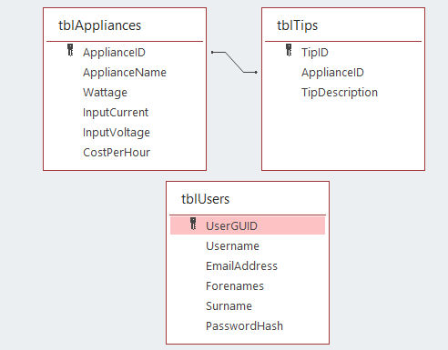

*Database table relationships*

**Task 3: Data Dictionary**

The application will make use of a JSON file “PowerhouseSave.json” to store the current state of the application including its’ active users and all the appliances associated with their account. Upon startup, the application will load all the save data from the JSON file into memory and then wait for the user to login to their account. Once the user logs in, the application will then get all of the ApplianceID’s that that user has attached to their name and retrieve the information for each of those appliances from the database “PowerhouseDb.mdb.” Multiple arrays will be required to efficiently carry out this process.

Sample text from PowerhouseSave.json:

{

    "type": "PhUsers_u.PhUsers",

    "id": 1,

    "fields": {

        "Users": [

            {

                "type": "PhUsers_u.PhUser",

                "id": 2,

                "fields": {

                    "m_GUID": "0FF54C0B80D24CB6B443C1C9BE95EC29",

                    "m_Appliances": [

                        1,

                        5,

                        21,

                        23,

                        30

                    ]

                }

            }

        ]

    }

}

Because a single user can have a large number of appliances and that there can be a potentially large number of users as well; certain getter functions in the ‘**PhUser**’ class will return variables by reference instead of by value using the ‘**out**’ keyword.

This architectural decision was made because these variables could potentially get way too large to efficiently pass them by value (creating copies of them when reassigning to new variables) which will bloat the memory used by the program. Additionally, this also assists in ensuring that different parts of the program will be able to properly modify the original instances of these variables instead of copies of them.

|  |  |  |
| --- | --- | --- |
| **Class Name** | **Attributes/Fields** | **Methods** |
| **PhAppliance** | **private** m_ID: uint32;  m_Name: string;  m_Wattage: real;  m_InputCurrent: real;  m_InputVoltage: real;  m_CostPerHour: real; | **public**  constructor Create(id: uint32; name: string; watt, ic, iv, cph: real);  GetID(): integer;  GetName(): string;  GetWattage(): real;  GetInputCurrent(): real;  GetInputVoltage(): real;  CalculateCostPerHour(): real;  **private**  UpdateInDatabase(); |
| **PhUser** | **private**  m_GUID: string;  m_Username: string;  m_PasswordHash: string;  m_Forenames: string;  m_Surname: string;  m_Appliances: TArray<PhAppliance>; | **public**  constructor Create(guid, usr, pswdHash, names, surname: string; appliances TArray<PhAppliance>);  GetGUID(): string;  GetUsername(): string;  SetUsername(usrName: string);  GetForenames(): string;  SetForenames(names: string);  GetSurname(): string;  SetSurname(surname: string);  GetAppliances(out result: TArray<PhAppliance>);  GetApplianceByName(name: string; out result: PhAppliance);  GetApplianceByID(id: integer; out result: PhAppliance);  **private**  UpdateInDatabase(); |
| **PhUsers** | **public**  Users: TArray<PhUser>; | **public**  constructor Create(); |
| **TJsonSerializer** | **private**  m_Marshal: TJSONMarshal;  m_Unmarshal: TJSONUnMarshal; | **public**  constructor Create();  SerializeJson(obj: TObject): string;  DeserializeJson(const jsonStr: string): TObject; |

**Task 4A: Navigation**

**Task 4B: Graphical User Interface**

LoginForm:

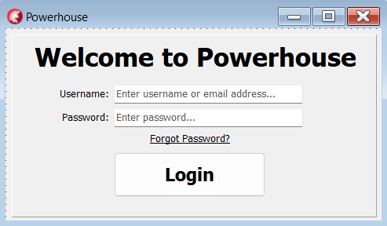

HomeForm:

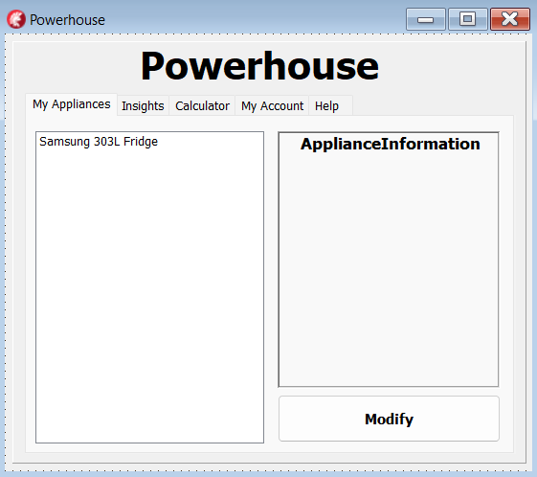

**Task 5: IPO**

**User login**

|  |  |  |
| --- | --- | --- |
| **Variable** | **Data Type** | **Description** |
| sUsername | String | Stores username/email address entered. |
| sPassword | String | Stores password entered. |

**Input, processing, output**

|  |  |  |  |  |
| --- | --- | --- | --- | --- |
| **Input** | **Source** | **Data Type** | **Format of the Input** | **GUI component** |
| Plain Text | Keyboard | String | Username/Password | TEdit |
| **Processing** | **Action** | | | **GUI Component** |
| Check if the username/email address exists in the database and then check if the hash of the inputted password matches the one in the database. | Check if sUsername and sPassword are not null. **If** they are null: display an error message.  **If** sUsername matches a username or email address in the database:  Hash sPassword, **if** hashed password matches the password hash in the database: successful login.  **else**  display “Incorrect password”  **else**  display “User doesn’t exist” | | | TButton |
| **Output** | **Format** | | | **GUI Component** |
| Open home form | Open home form populated with all the relevant personalized information pertaining to the user logged-in. | | | TForm |

**Loading user information**

|  |  |  |
| --- | --- | --- |
| **Variable** | **Data Type** | **Description** |
| arrAppliances | TArray<PhAppliance> | Array of appliances from “PowerhouseSave.json” which are attached to the current user. |
| tPowerhouseSave | TextFile | Logical text file used for loading data into arrAppliances. |
| sLineBuf | String | Buffer used for reading in each line from tPowerhouseSave. |
| sPowerhouseSave | String | Complete string containing all text read into sLineBuf. |

**Input, processing, output**

|  |  |  |  |  |
| --- | --- | --- | --- | --- |
| **Input** | **Source** | **Data Type** | **Format of the Input** | **GUI component** |
| Plain Text | Text file “PowerhouseSave.json” | String | JSON | None |
| **Processing** | **Action** | | | **GUI Component** |
| Assign tPowerhouseSave. Populate arrAppliances from tPowerhouseSave and assign all the data to m_Appliances of the current instance of the PhUser class. | Assign and reset tPowerhouseSave.  Read all text from tPowerhouseSave into sPowerhouseSave.  **If** error reading file: display error.  Unmarshal sPowerhouseSave JSON text and populate arrAppliances.  **If** error unmarshalling text: display error.  **for** appliance **in** arrAppliances **do**  Fetch all appliance information from “PowerhouseDb.mdb” using ApplianceID.  Assign newly populated arrAppliances to m_Appliances of the current instance of the PhUser class. | | | TTabControl |
| **Output** | **Format** | | | **GUI Component** |
| Show home form with personalized information. | Open home form populated with all the relevant personalized information pertaining to the user logged-in. | | | TForm |